MCSD Foundation

Marco van der Merwe

ctu | roodepoort

Combined year project

Final project group 4

Email: [Marcovandermerwe2000@gmail.com](mailto:Marcovandermerwe2000@gmail.com)

ICAS: 4861

ID: 0001175063088

# Table of content:

Contents

Table of content: 1

Introduction: 2

SQL Code for creating database: 3

Tables with attributes created in the database: 3

Connect.php code provided: 5

Conclusion: 6

# Introduction:

This document will contain screenshots provided as evidence for creating a database with all its required tables and attributes for the MCSD Students to connect the website to. The database was created using SQL Management Studio.

# SQL Code for creating database:

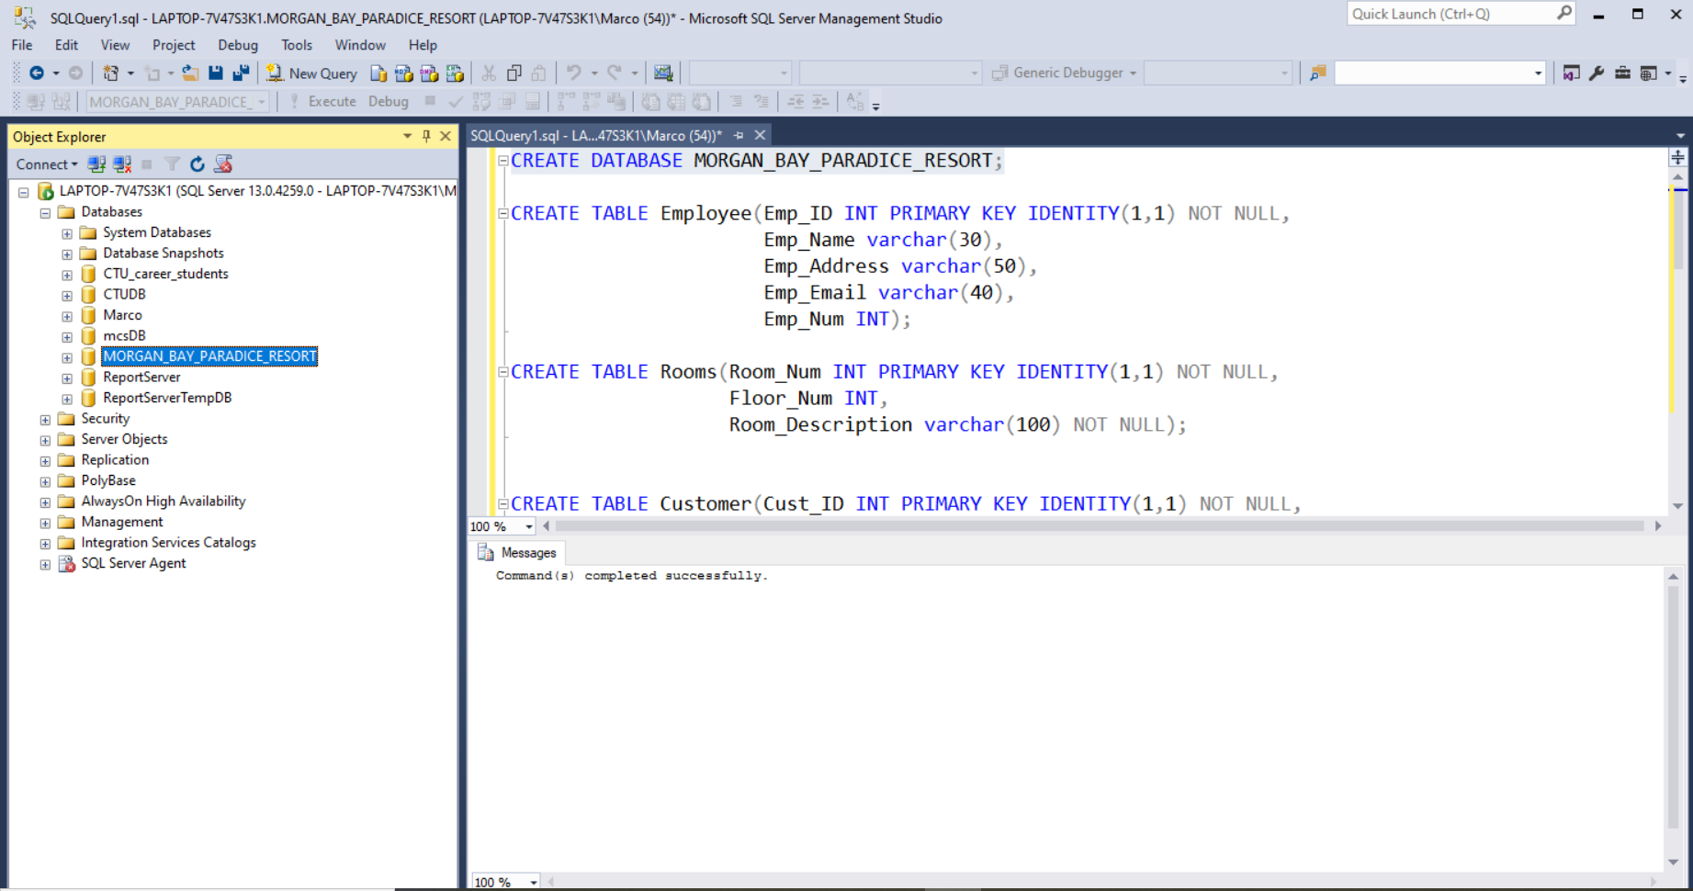Figure

# Tables with attributes created in the database:

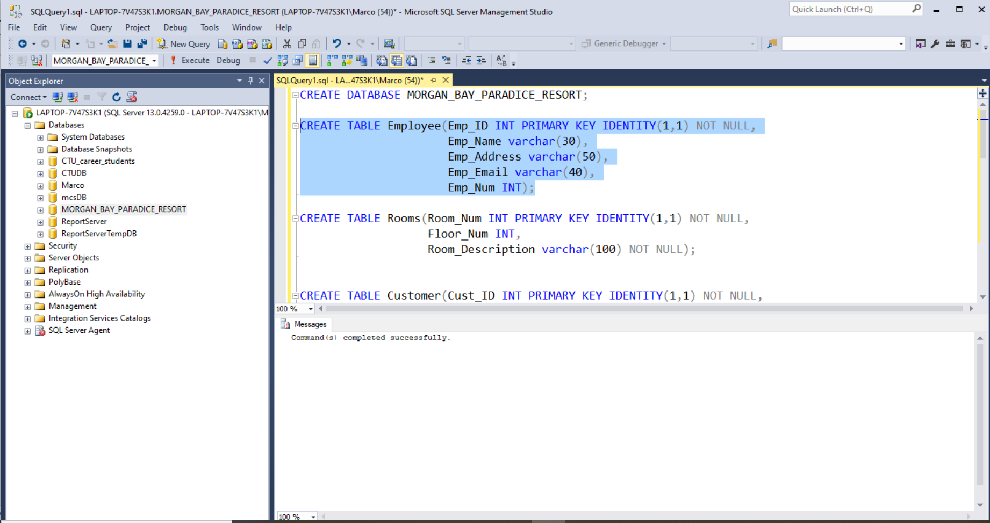Figure

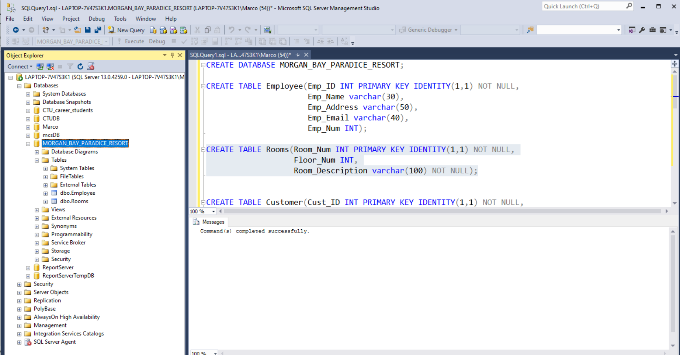Figure

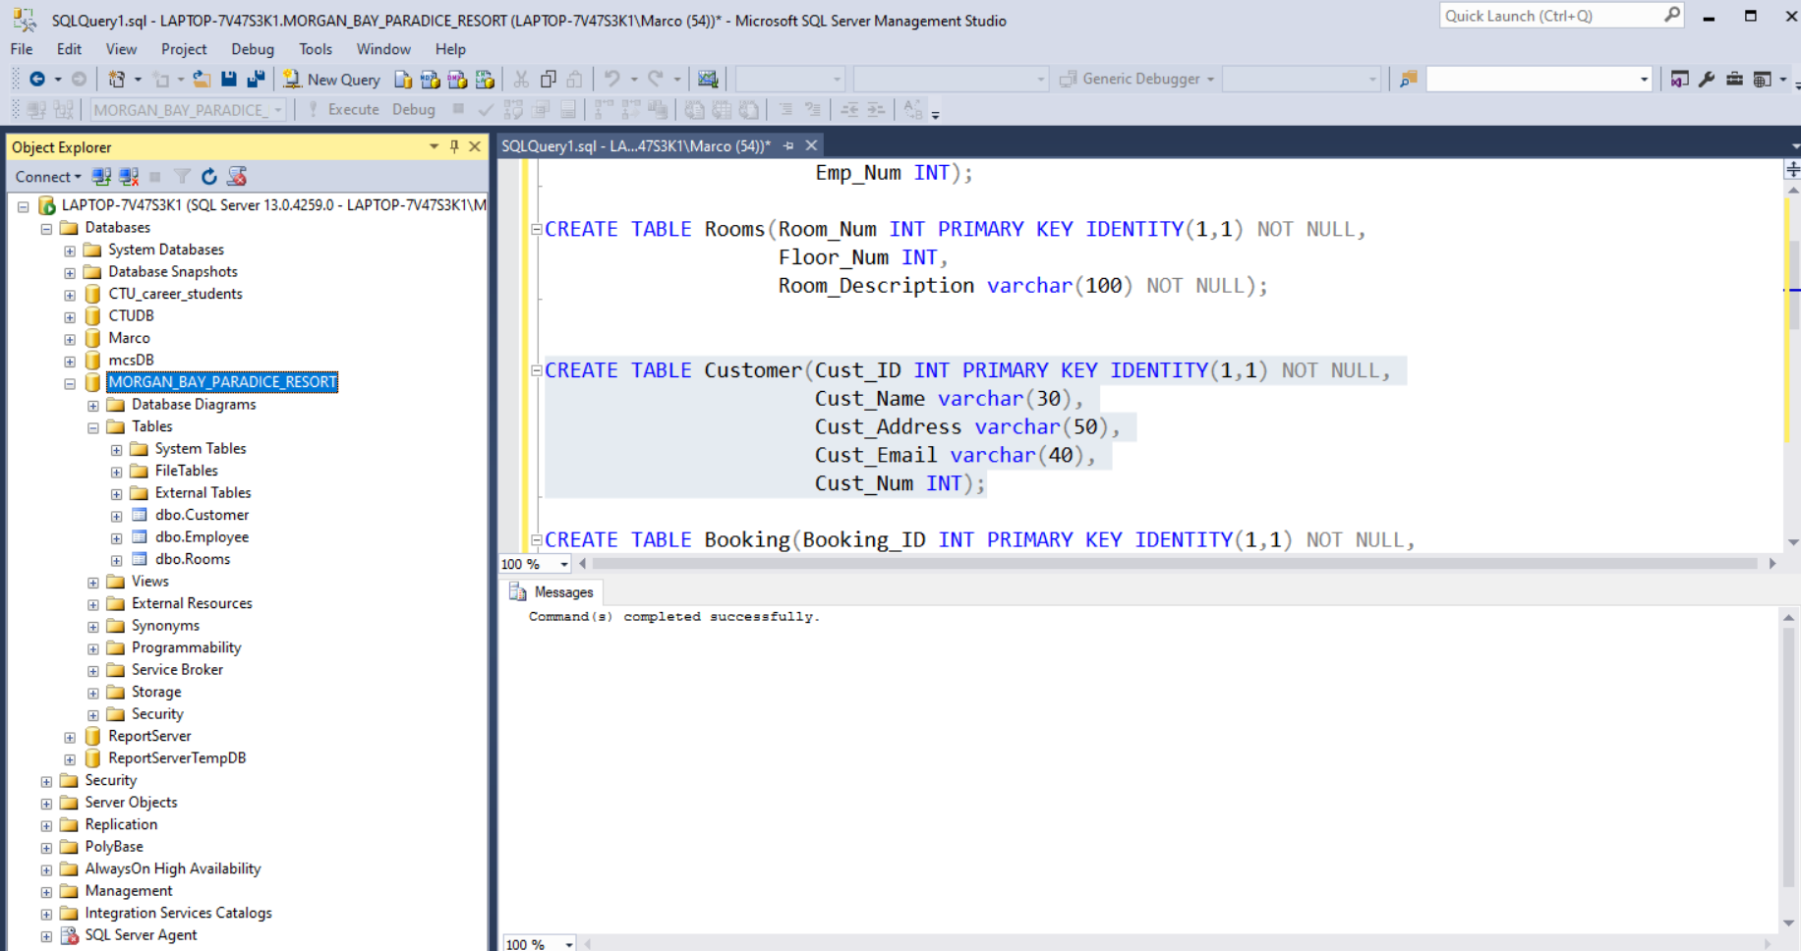Figure

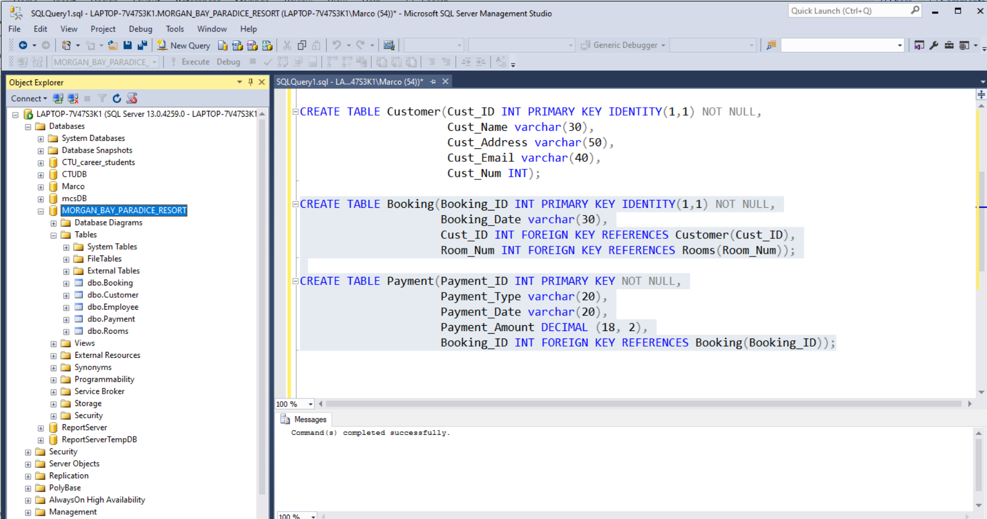Figure

# Connect.php code provided:

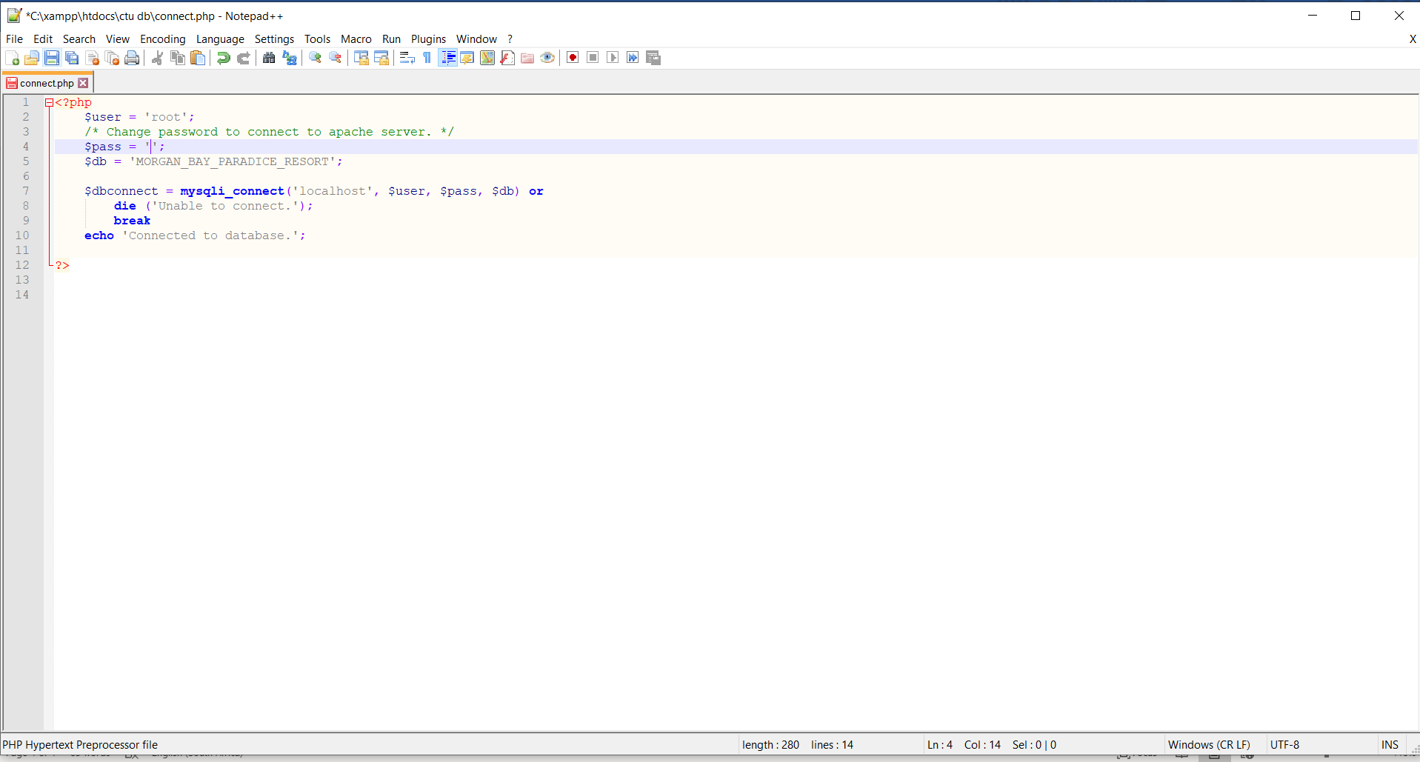Figure

# Conclusion:

In conclusion we have created a database within SQL management studio for the MCSD students to use when connecting their website to a database. They will make use of the above database as required.